//

// Text Document

// 05 Task Performance 1 - 05_Task_Performance_1.docx

//

// ========== // ========== // ========== // ========== // ========== //

// //

// Select a specific web application or website related to //

// programming or designing. Then, answer the following items: //

// 1. Provide the name of the web application/website. //

// 2. Provide the link to the web application/website. //

// 3. Briefly describe the web application/website. //

// 4. What type of UI does the web application/website //

// encompasses? Justify your answer. //

// 5. Take a screenshot of at least 2 different //

// event-driven program execution that you have noticed //

// in the web application/website. //

// 6. Based on your answers on item number 5, rationalize //

// how each screenshot encompasses event-driven //

// program execution. //

// //

// ========== // ========== // ========== // ========== // ========== //

1. Github
2. <https://github.com/>
3. This website provides an easy way for developers to store and manage their projects, codes, programs, etc. This website is commonly used to host open sourced software development projects.
4. This website uses Graphical User Interface as its UI. Most websites nowadays uses GUI as it is easier, more efficient, and better to use than other UI.

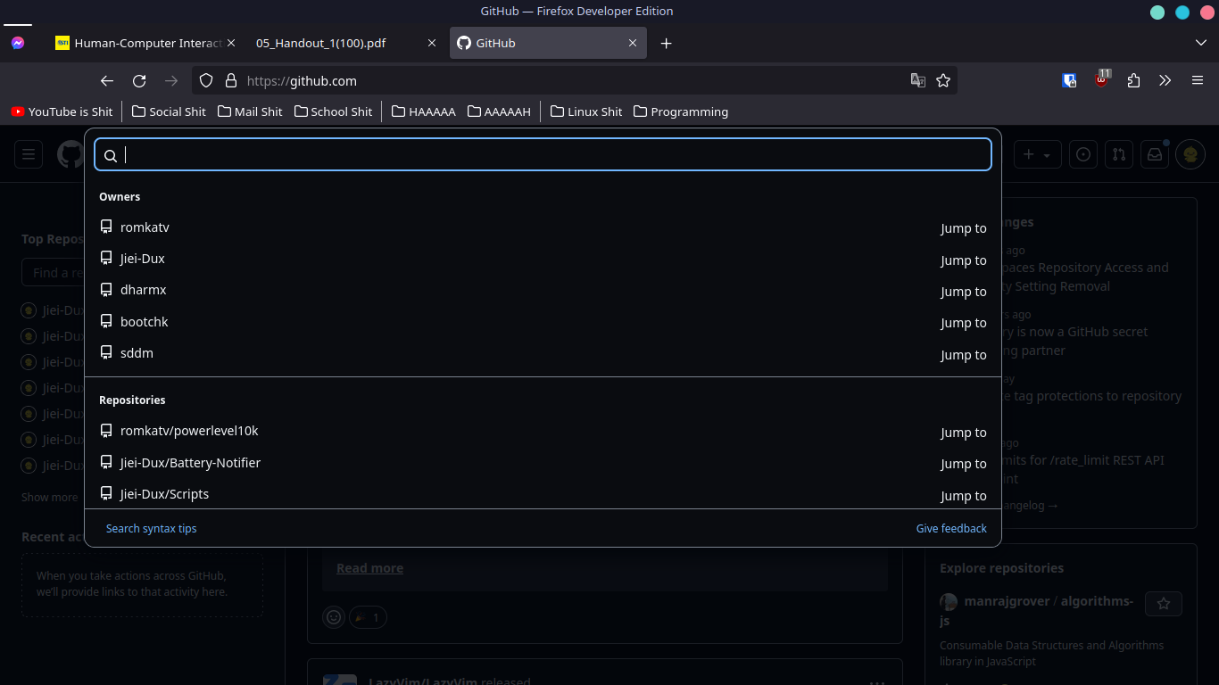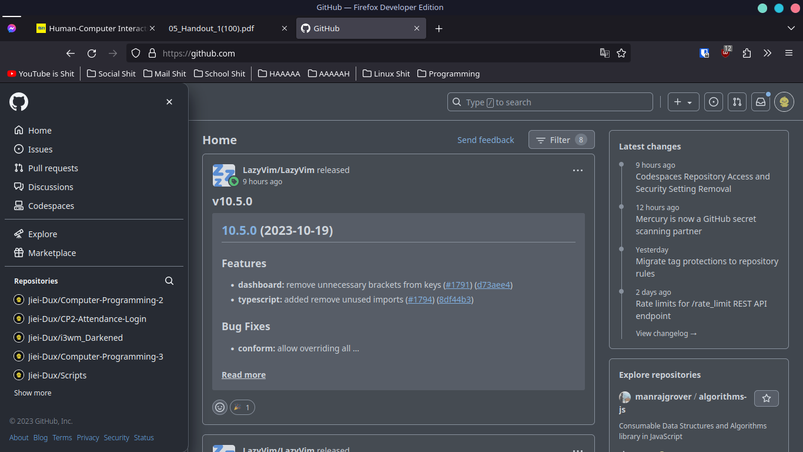

1. Basically, these will only appear if the user clicked on them... The event being the mouse click...